Fall Registration Forms
The 2020-2021 Fall Registration forms were sent out via email. If you need a new one, extras can be found on the entryway counter. Please hand yours in, as it is very important for budgeting and scheduling. You will be sent a confirmation with your new tuition rate for fall and your new vacation coupons for the year.

Any Orange vacation coupons that you have remaining will be honored through the end of the year, expiring on December 31, 2020.

4 Year Old Pre-K Program
As the new school year approaches, we want to encourage any family who may have questions regarding our 4 year old Pre-K program to contact Miss Becca. She would be more than happy to talk with you. You may email her at graftonprek@ozaukeechildcarepreschool.com

Pajama Day
Take advantage of our pajama day on August 19th by rolling your kiddos out of bed and heading straight to the center!

End of Summer Party
As summertime comes to an end, we want to go out with a bang!! Thursday, August 27th will be our end-of-summer party! Each classroom will plan fun activities for their classroom and a special treat will be served!

Welcome New Families!
Hazel Shively – Infants
Frankie Tozzi – 2 Year Olds
Louie Tozzi – Pre-k
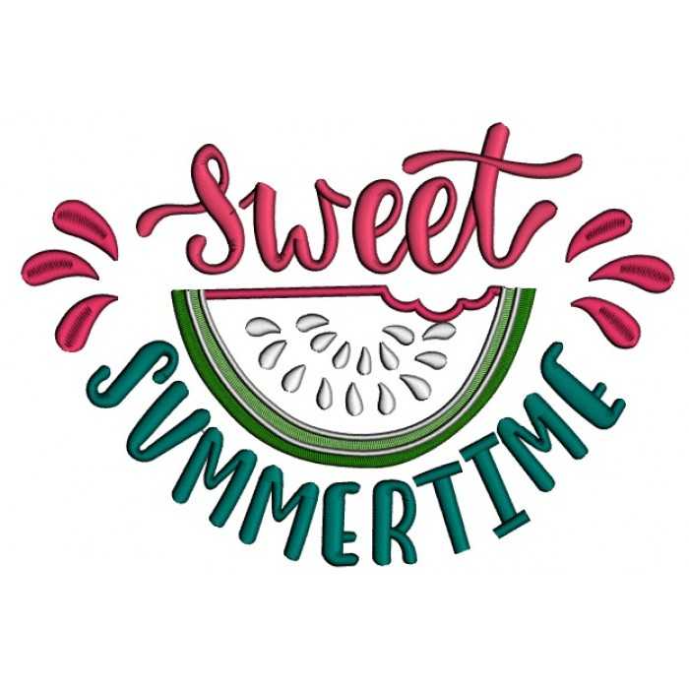

Student Assessments
The teachers are diligently working on the children’s assessments. Please keep in mind that these are based on observations here at the center. They will be handed out at the end of August. If you would like to set up a conference, please let Miss Ashley or Miss Pamela know.

Happy Birthday!
Miss Kristen is ??? on Aug. 5th
Charlotte H. is 2 years on Aug. 6th
Caroline S. is 7 years on Aug. 15th
Mila T. is 5 years on Aug. 15th
Mia A. is 4 years on Aug. 15th
Lena S. is 4 years on Aug. 17th
Kaden D. is 1 year on Aug. 20th
Max S. is 6 years on Aug. 23rd
Miss Ginni is ??? on Aug. 28th
Theo L. is 2 years on Aug. 29th

Happy Anniversary!
Miss Heather – Aug. 3rd 5 years!!!!!
Miss Lindsay – Aug. 11th 6 years!!!!!!
Miss Ginni – Aug. 27th 7 years!!!!!!!
Miss Tamrah – Aug. 27th 2 years!!
Miss Emily – Aug. 28th 3 years!!!

Holiday Closing
A reminder that we will be closed Monday, September 7th to observe Labor Day. Remember if this is your child’s regularly scheduled day, you need to pay the normal rate or turn in a vacation coupon.

Operating Hours
A reminder that on August 3rd our operating hours are being adjusted to 6:30am-5:30pm. On September 8th they will be adjusted once again to 6:30am-6:00pm.

