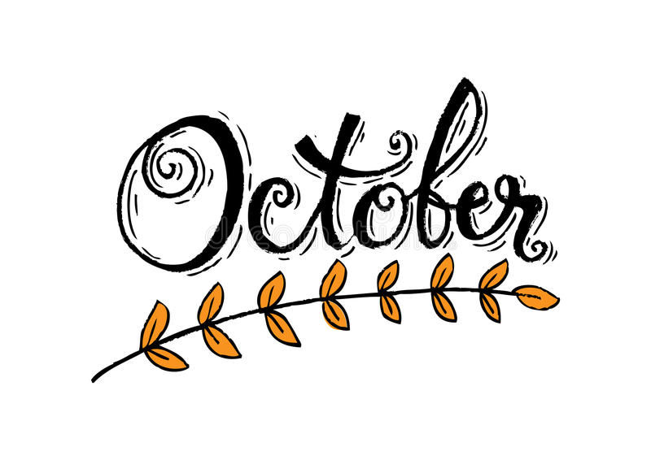
www.ozaukeechildcarepreschool.com
As fall settles in we would like to remind all families to bring in weather appropriate extra clothes for your children. Jackets, hats and mittens should be here as well as the weather continues to cool.
The week of October 5th-9th is Fire Prevention Week. Each classroom will be working on activities that promote fire safety awareness. Ask your child to share with you what they have learned this week!
Monday, October 19th will be our much-loved Pajama Day! Make it easy on yourself and roll the kiddos out of bed and head right in!!
The Grafton School District will be closed on October 16th and 30th for all students and October 29th for 4K only. Please reach out to Ashley if you are in need of care for your school-aged child any of these days!
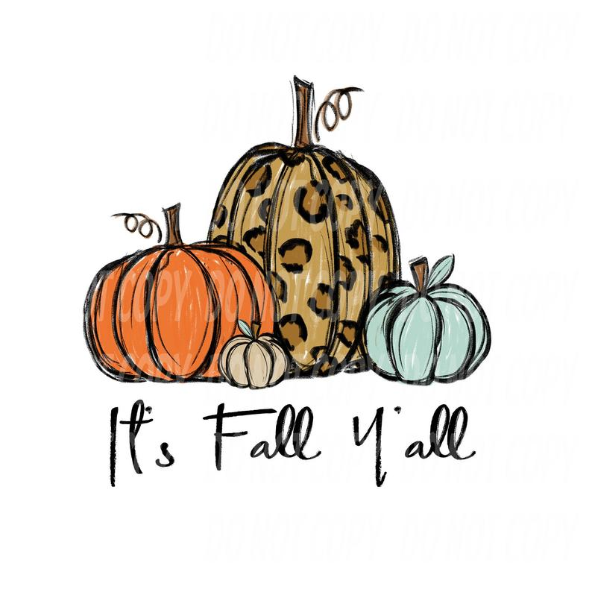
We would like to give a warm OCCP welcome to some new families!!
- Ethan Ebbert in the Older Ones Room
- Ollee Mader in the Infant Room
- Ray Manderscheid in the Inf/Toddler Room
- The Rennicke Family in the Infant Room
- Connor Kula in the Older Ones Room

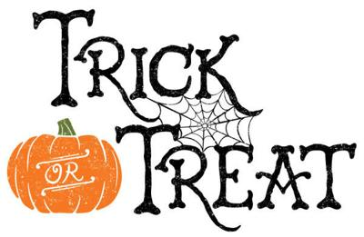
Get ready for a spooky, silly day on Wednesday, October 28th! Each classroom will have their own Halloween party complete with treats, games and amazing costumes had by all!! Keep an eye out for your child’s classroom newsletter that will give you more details on what to expect in their room!! A special snack sign-up may be posted as well!
We would like to wish a very Happy Birthday to:
- Clara Henke on the 17th
- Isla Darin on the 18th
- Jasper Eggert on the 24th
- Beckett Olejnizak on the 25th
- Kate Geiger on the 30th
We are looking to update our parent references that we include in the touring packets we hand out to potential new families. If you would like to share your positive experience by either being a parent reference by providing your email or phone number or writing a testimonial, please let Miss Pamela know.
Happy Anniversary to:
Miss Ashley on October 13th -12 years!!!!!!!!!!!!
Miss Pamela on October 16th – 2 years!!
Miss Lisa on October 17th – 20 years!!!!!!!!!!!!!!!!!!!!

Happy Fall Y’all !!!!

