OCTOBER NEWSLETTER
www.ozaukechildcarepreschool.com

Cold Weather Reminders
As fall settles in, we would like to remind families to check your child’s cubbies to ensure they have enough weather appropriate, extra clothes that fit. Jackets, hats and mittens can be brought in as it is getting cooler. Boots and snow pants soon too!!
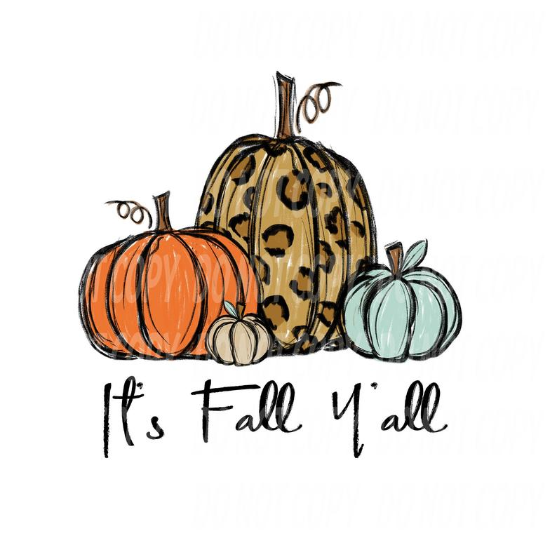
Upcoming Events
We have some upcoming events planned for the centers. Please mark your calendars for the following dates!
October 13th Be a pumpkin and wear ORANGE to school
October 18th Dress up as a Community Worker (policeman, doctor, construction worker etc..)
October 31st - Halloween Party! Each classroom will host their own Halloween Party and then trick-or-treat to each of the classrooms. Please look for more details from your child’s classroom newsletter.

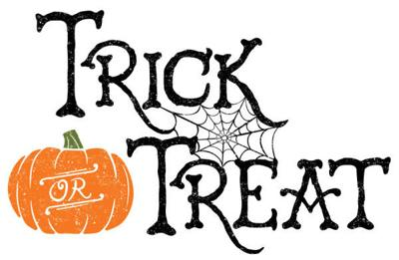

SAY CHEESE…..
OCC is having picture day for all enrolled children. If it is your scheduled day off, you are welcome to come in during the morning hours before 12:00pm to have your child’s picture taken. Please be sure to watch for an email and look for advertisements being posted.
Mequon Center picture day is November 2nd
Grafton Center picture day is November 9th
Friendsgiving & Pie with parents
On Tuesday, November 15th, all of our classrooms will share in a “friendsgiving” meal with their teachers and classmates in anticipation of Thanksgiving. We would like to invite all parents to join their children at 3:15pm this day to enjoy a piece of Thanksgiving pie with us. Mark your calendars and reserve the date! If you are interested in donating a pie or other dessert for the event, please sign up at the entranceway counter. Hope to see you then!
HOLIDAY CLOSINGS
Attached is the 2023 Holiday Closings lists. A reminder that full weekly tuition is due when there is a holiday. However, you are able to turn in a Vacation Coupon for that day.
EVENING PICK UPS
Please be respectful of the classrooms you enter and exit through when picking your children up from the playground. Do not allow your children to spend time playing in the classrooms, as our staff have closed down the rooms for the day and cleaned toys/equipment preparing for the next day.

A MESSAGE FROM MEQUON

Happy Birthday To You!!!
Mason S. turns 1 on the 8th
Reid F. turns 5 on the 12th
Jack K. turns 3 on the 14th
Mackenzie S. turns 3 on the 22nd
Miss Brenda on the 31st

Happy Anniversary To You!!
Ms Leanne – 5 years on Oct. 2nd!!!!!
Ms Brenda – 17 years on Oct. 3rd!!!!!!!!!!!!!!!!!
Ms Lisa – 22 years on the 13th!!!!!!!!!!!!!!!!!!!!!!
Ms Pamela – 4 years on the 16th!!!!

THE GOSSIP IN GRAFTON

Welcome New Families
Colbie K. in the Infants
Hailey C. in the Infants
Rhea O. in the Infant/Toddlers
Ruby O. in the Threes
Jesse R. in the Threes

Happy Birthday To You!!!
Addison M. turns 2 on the 13th
Ms Mia on the 19th

Happy Anniversary to you!!
Ms Lisa – 22 years on the 17th!!!!!!!!!!!!!!!!!!!!!!
Ms Ashley – 14 years on the 13th!!!!!!!!!!!!!!
Ms Pamela – 4 years on the 16th!!!!

